# Chapter 3

## What is White box test?

* It is aiming to cover every possibilities of the code.
* Every possibilities?
  + 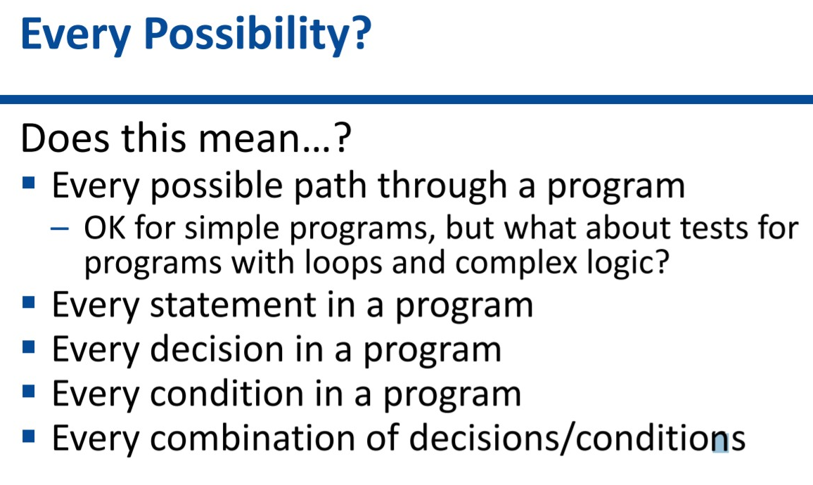

## What is the differences between white/black box test?

## White-box test types

### Static analysis

* Techniques: Code Inspection
* 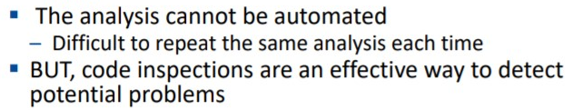

### Dynamic

* Techniques: **Path Coverage**. If there are many combination, draw a **decision tree**.
  + 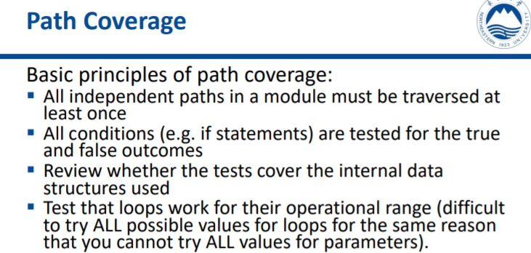
  + 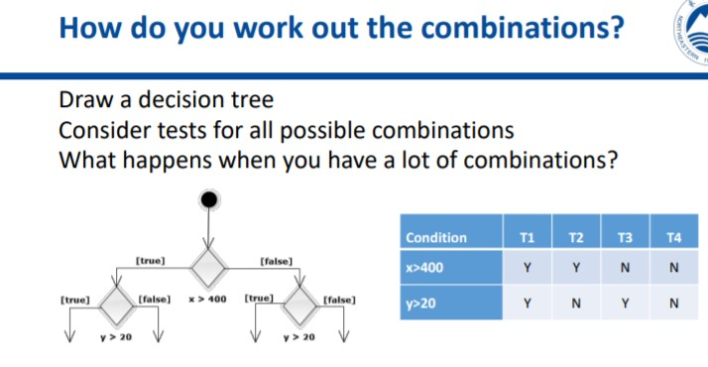
  + **Control flow graph** is also used to understand the connection between parts of code and to analyze the **Cyclomatic Complexity**.

 

  